Answer-1: Screen-shots of various WebUI of hadoop-cluster

Figure-1: JobTracker portal

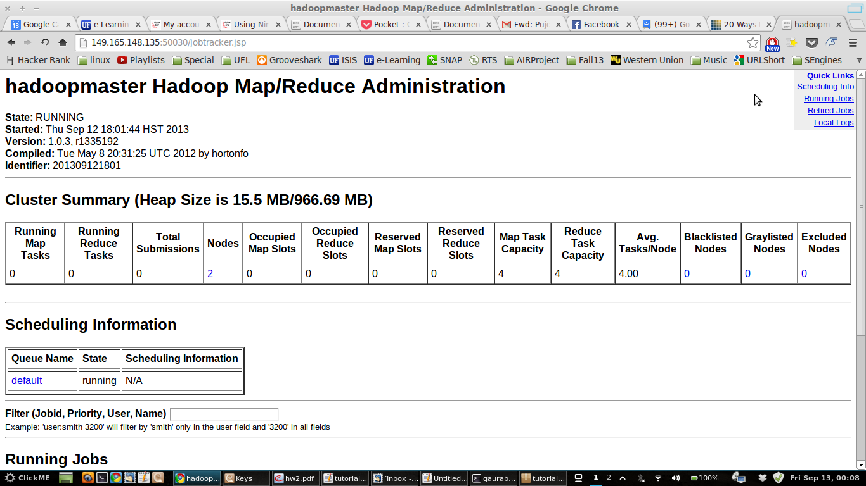

Figure-2: Map-Reduce Portal
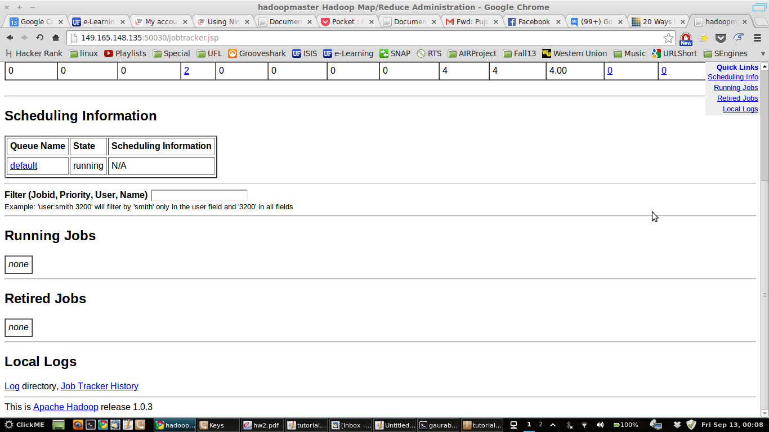
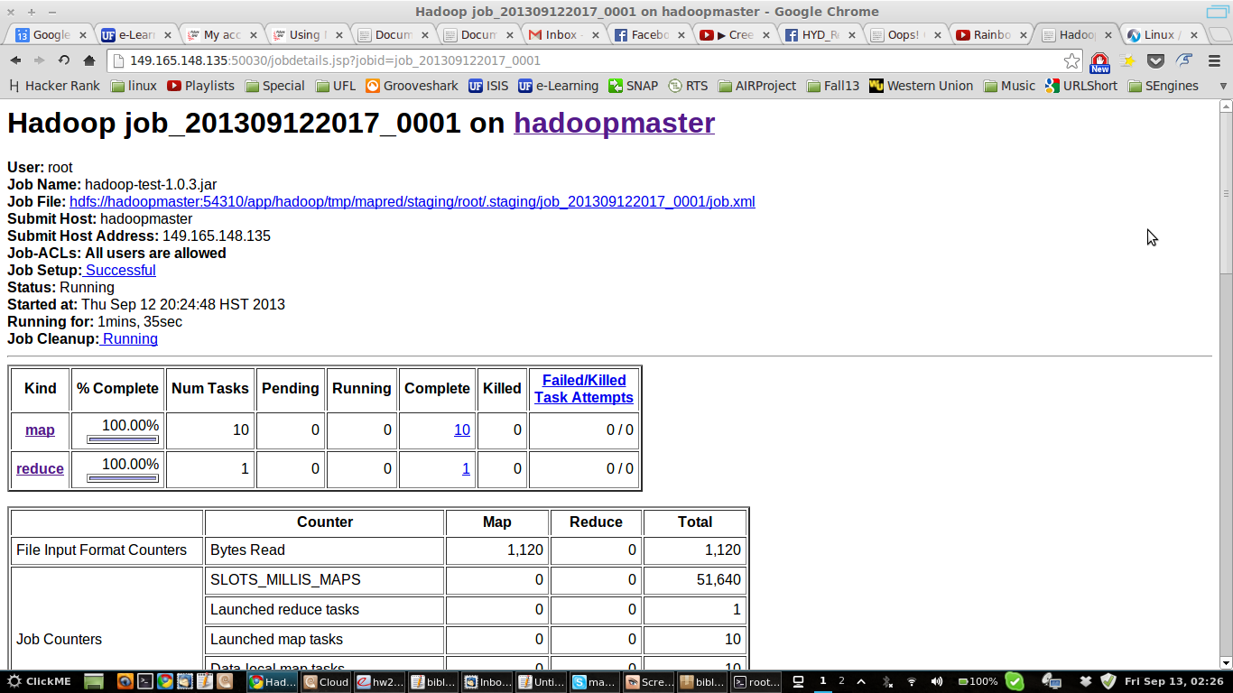

Figure-3: Map-Reduce Completion Graphs

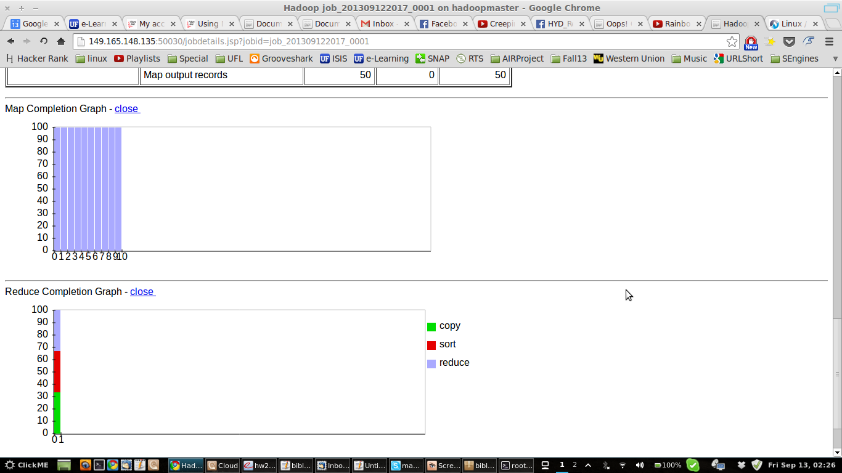
Figure-4: Map Task list

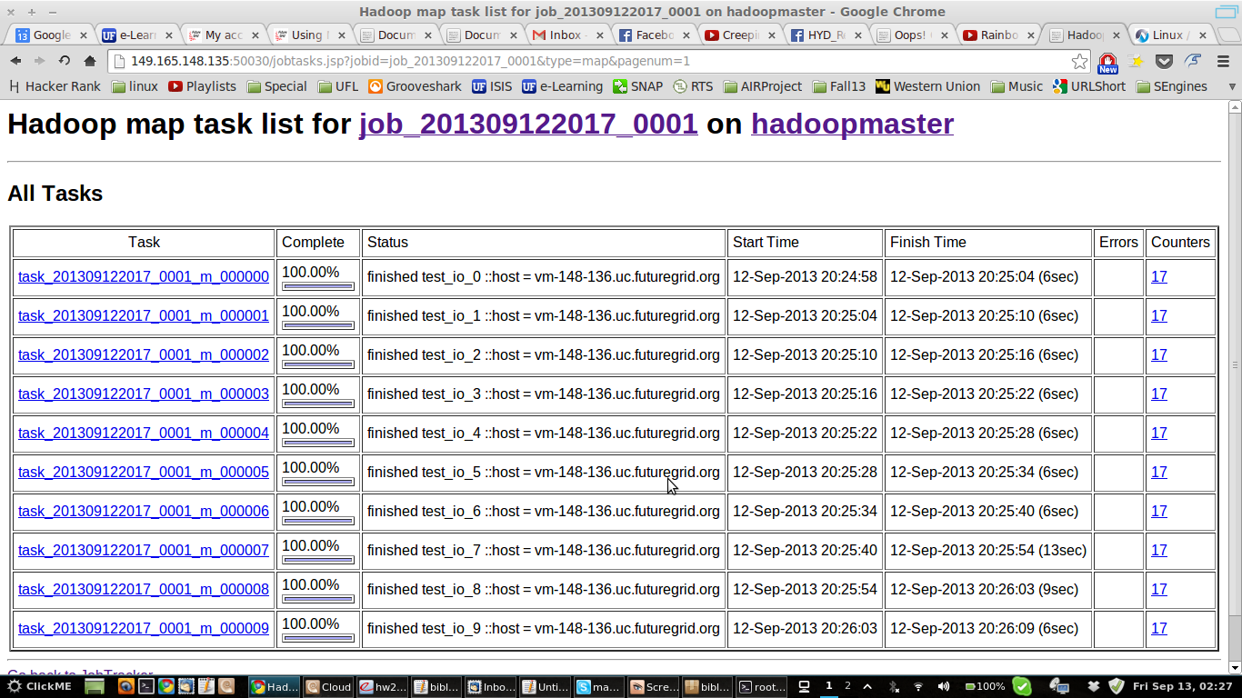

Figure-5: Reduce Task List
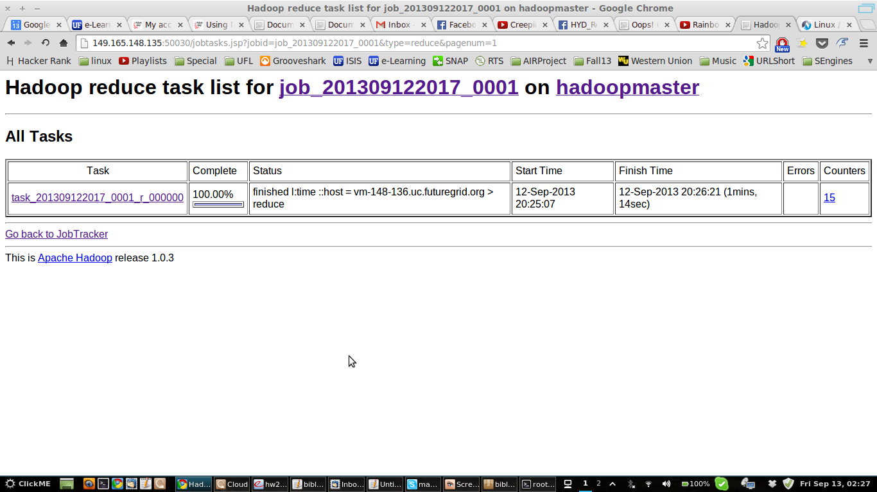

Figure-6: Screen-shot of TestDFSIO on hadoop cluster

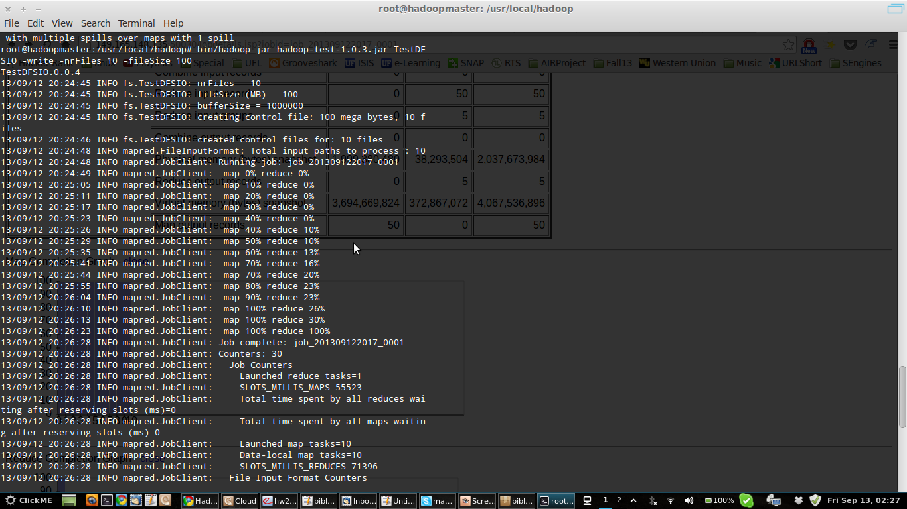

Answer-2:
Application: TestDFSIO
Details: Its benchmark testing code for HDFS read and write. It is used to detect performance bottleneck in hadoop cluster network. The output of the test can be used to optimize hardware, OS and cluster environment for better performance.

Processing: TestDFSIO is design to create only one file and one-to-one mapping from files to map tasks. Split structures are created in a way that each map service gets only one file name for write or read. It measures the three parameters for each operation:
- size of file
- time taken for the task
- rate (size/time)

